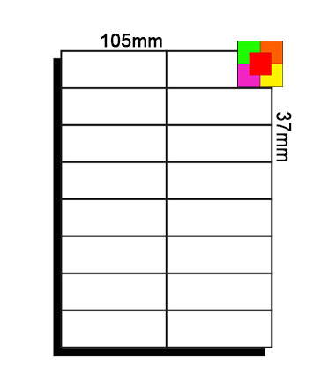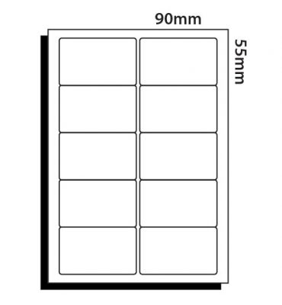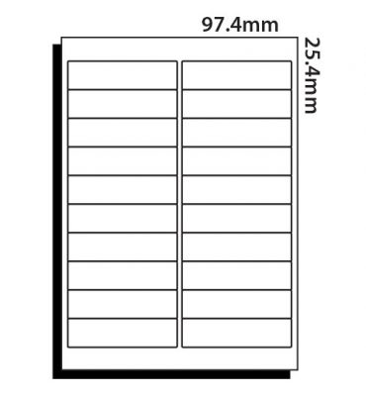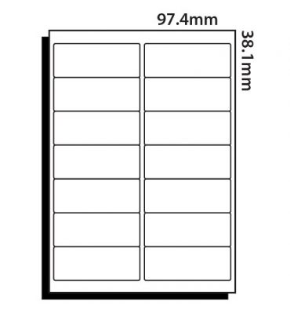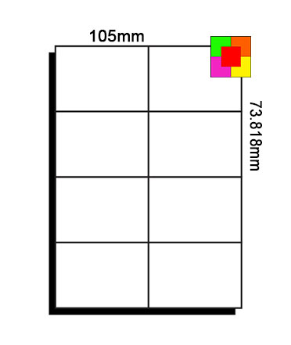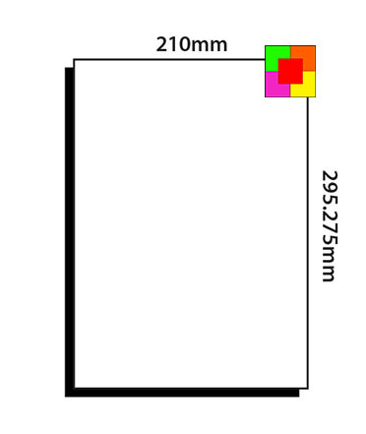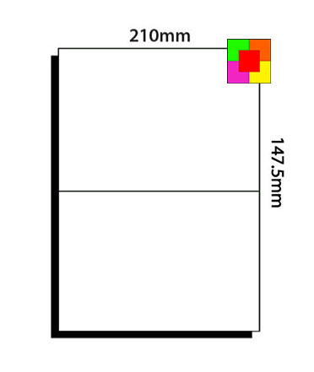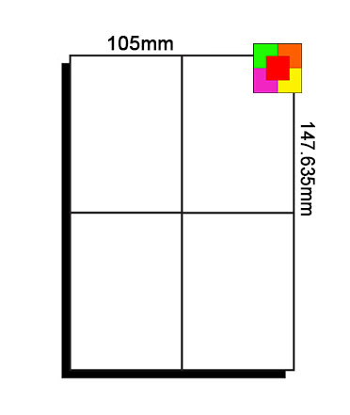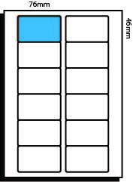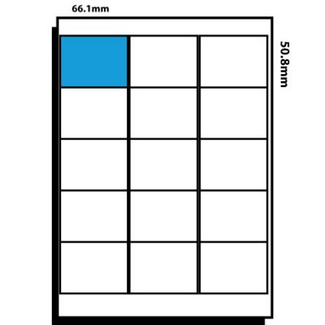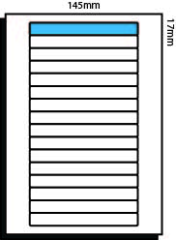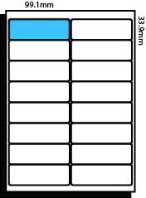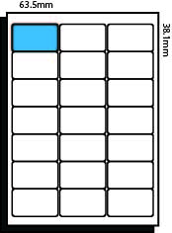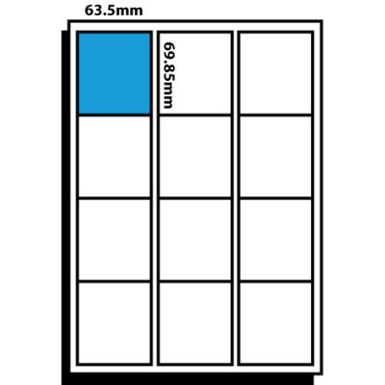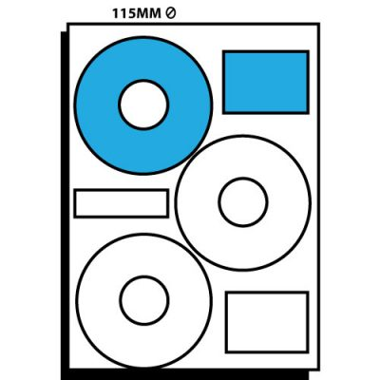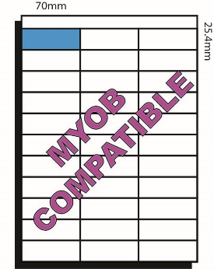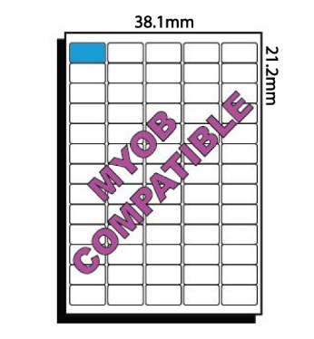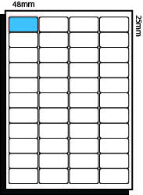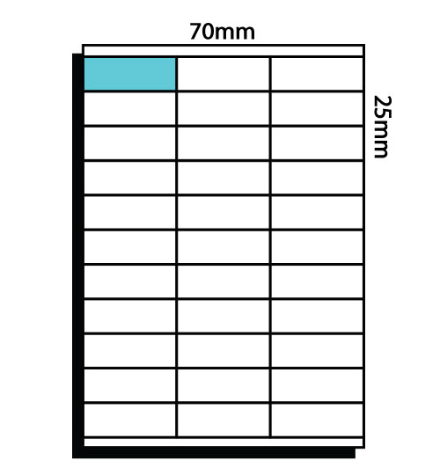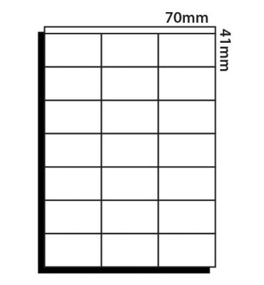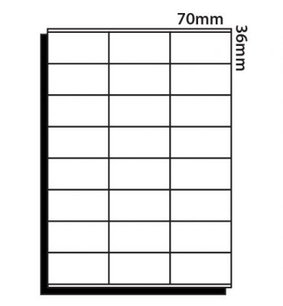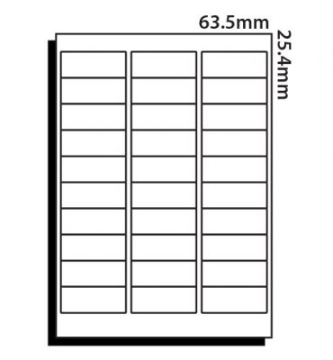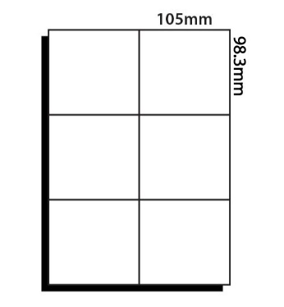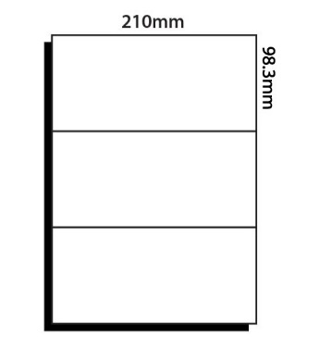 **A4 Copier / Laser / Inkjet Sheet Labels**

*Updated Oct 2017*

**PD15 VS16 VF12 WP16 WP21**

**66.1 x 50.8mm 145 x 17 mm 76 x 46mm 99.1 x 33.9mm 63.5 x 38.1mm**

**CL65 CL65R CDL33 CD03 PD12**

**38.1 x 21.2mm 38.1 x 21.2 mm 70 x 25.4mm 115mm DIA 63.5 x 69.9mm**

**CL08 CL10 CL14 CL16 CL20**

**105 x 73.8mm 90 x 55 mm 97.4 x 38mm 105 x 37mm 97.4 x 25.4mm**

**CL21 CL24 CL30 CL33 CL44**

**70 x 41mm 70 x 36 mm 63.5 x 25.4mm 70 x 25mm 48 x 25mm**

**CL01 CL02 CL03 CL04 CL06**

**210 x 295mm 210 x 147.5mm 210 x 98.3mm 105 x 147.5mm 105 x 98.3mm**